Project Milestone-01

Project title: Property Management.

Project Description:
This project deals with a website where we have information about the properties and their records. It maintains the user's information, and other details required for the purchase. It also contains all kinds of data regarding the property like locations, dates of the properties, description, previous owners, property age etc.

Team name: Aces

Team member names:
- Jahna Sri Aneela Ankam.
- Saisumithra Jagarlamudi.
- Sowmya Yalamarthi.
- Padmini Duggirala.
- Manisha Mandapati.

Client: Dr. Aziz Fellah

Team Logo:



Working as a team together:
We will take collective responsibility for completing the project on schedule and without compromising on time and budget constraints.

Team meetings:
We are planning to meet in zoom and discuss the daily progress of the project, issues if any, and further implementations.

Contacting each other:
We are planning to communicate through Microsoft mail, teams, and a few in person meetings.

Dealing with a non-participating team member:
If a team member is not taking active participation in the project, as a team we need to take the responsibility and enquire about their problem and make that person engage in all the activities and assign him/her work in their field of interest.

Roles | Responsible Team members
Developer | Jahna Sri Aneela Ankam
Developer | Saisumithra Jagarlamudi
Developer | Sowmya Yalamarthi
Tester | Padmini Duggirala
Scrum Master | Manisha Mandapati

Team Roles:
- Discuss and develop a project plan.
- Ensure proper communication between the entire team.
- Use available tools and resources to help team members.
- Document and analyze project requirements
- Conduct motivation and team building sessions.
- Keep track on the progress of the project.
- The team lead should take care that all the team members are participating actively.

UI Developer:
- Work with other developers to make sure the website is both usable and pleasing to the eye.
- Consult with the client to determine their requirements and goals.
- Make a website layout plan.
- Ascertain that the website is compatible with a variety of devices.
- Analytical tools can be used to gauge client satisfaction.

Backend Developer:
- The backend developer's task is to figure out what the website's goals are and come up with practical solutions.
- Data storage as well as ensuring that it is visible to the users who are supposed to have access to it.
- Responsibilities include designing a payment processing system that accepts data, securely stores it, and charges it.

Tester:
- A Software Tester is responsible for creating usability testing scenarios.
- He / She is in charge of performing the testing, analyzing the data, and reporting his findings to the development team.
- He will need to work with clients to better understand product specifications or whether the design needs any changes.
- Software testers are often held accountable.

Scrum Master:
- Planning and advising Scrum implementations within the company.
- Leading, teaching, and coaching the organization in its Scrum adoption.
- Assisting workers and stakeholders in comprehending and putting into practice an analytical approach to complex work.
- Stakeholders and Scrum Teams are no longer separated.

Project Charter
Date

Project Title: Property Management (Managing properties in a particular area)
Project Start Date: May - 11 - 2021 Projected Finish Date: Jun – 03 - 2021
Budget Information: Sponsors.

Project Manager:
Name : Jahna Sri Aneela Ankam
Phone : 660-528-1262
E-mail : S541988@nwmissouri.edu
Project Objectives:
To create a website which gives the information about the properties that are available for sale.
Success Criteria:
Finishing the project on time and making sure it's online, error-free, and has a responsive and user-friendly GUI.
Approach:
Agile approach

Roles and Responsibilities
Name and Signature | Role | Position | Contact Information
Jahna Sri Aneela Ankam | Project Manager/Web application Developer | Developer | S541988@nwmissouri.edu
Saisumithra Jagarlamudi | Team lead/ Backend developer | Developer | S542361@nwmissouri.edu
Sowmya Yalamarthi | UI Developer | Developer | S542049@nwmissouri.edu
Padmini Duggirala | Testing Manager | Tester | S542358@nwmissouri.edu
Manisha Mandapati | Scrum Master | Scrum Master | S542043@nwmissouri.edu

Stakeholder Register for Project Management

Prepared by: Jahna Sri Aneela Ankam Date:05/15/2021
Name | Position | Internal/External | Project Role | Contact Information
Jahna Sri Aneela Ankam | Project Manager/Web application Developer | Internal | Developer | S541988@nwmissouri.edu
Saisumithra Jagarlamudi | Team lead/ Backend developer | Internal | Developer | S542361@nwmissouri.edu
Sowmya Yalamarthi | UI Developer | Internal | Developer | S542049@nwmissouri.edu
Padmini Duggirala | Testing Manager | Internal | Tester | S542358@nwmissouri.edu
Manisha Mandapati | Scrum Master | Internal | Scrum Master | S542043@nwmissouri.edu
Aziz Fellah | Client | External | End User | afellah@nwmissouri.edu

Signatures :

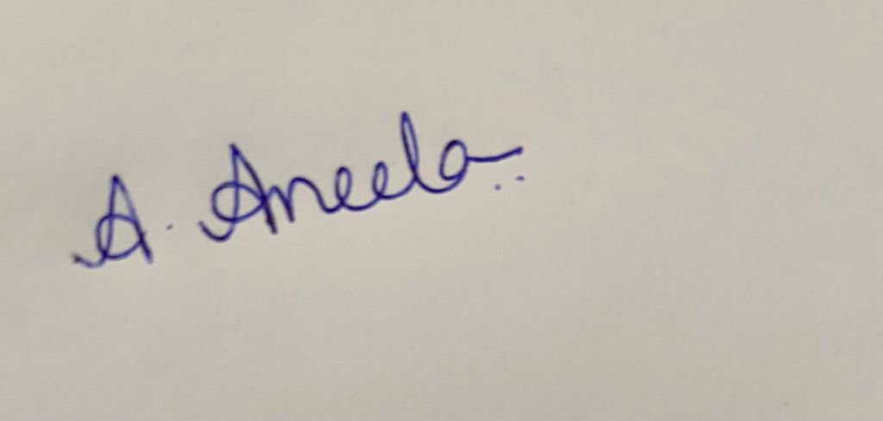
Jahna Sri Aneela Ankam

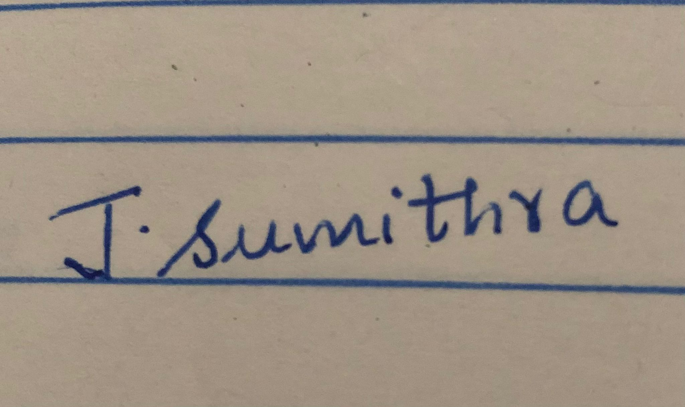
Saisumithra Jagarlamudi

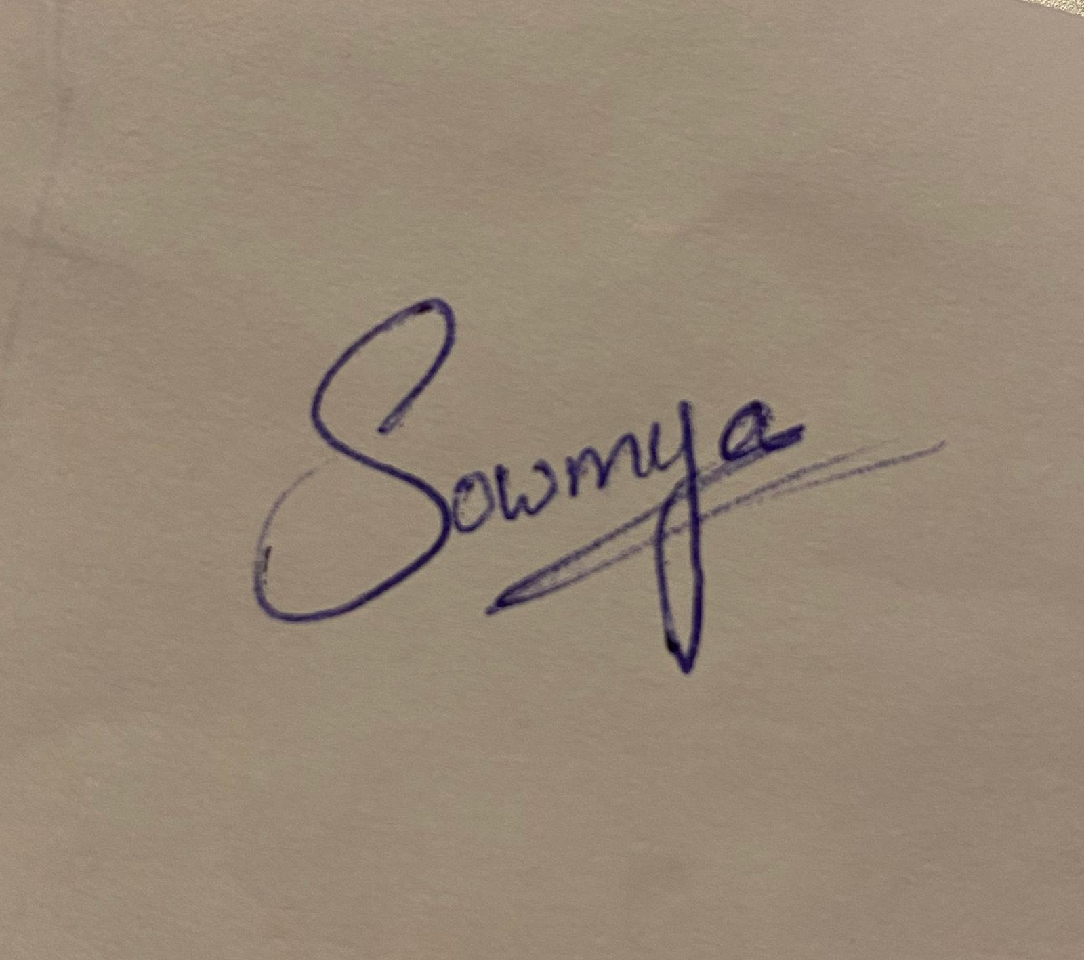
Sowmya Yalamarthi


Padmini Duggirala

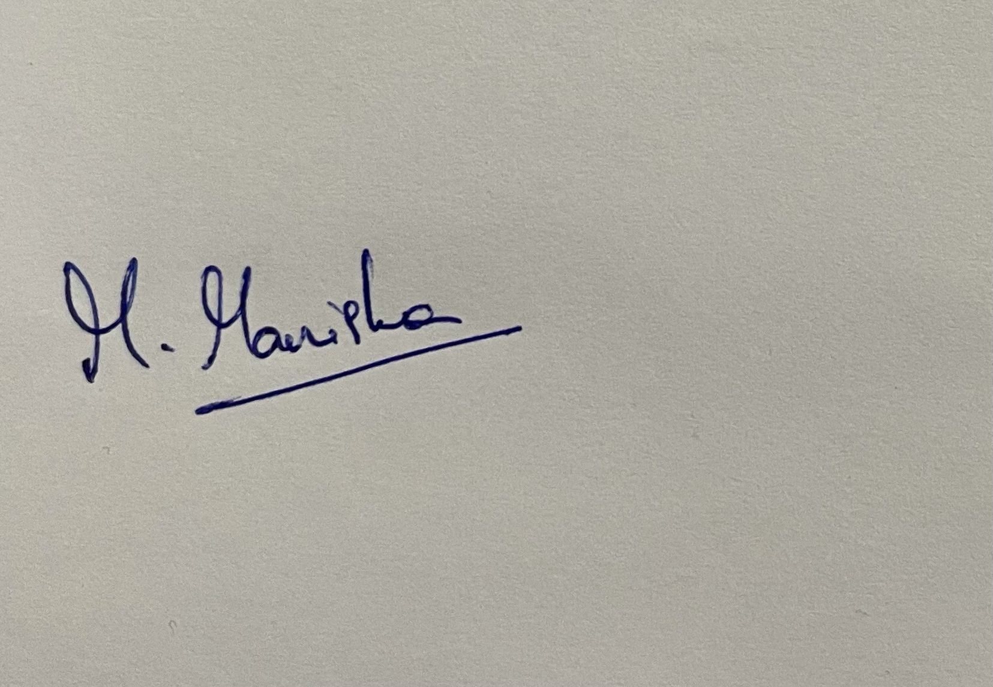
Manisha Mandapati

